**NAME :** SUGAPRIYA M

**DEPARTMENT :** INDUSTRIAL BIOTECHNOLOGY

**COLLEGE :** GOVERNMENT COLLEGE OF TECHNOLOGY

**NAAN MUDHALVAN COURSE :** DIGITAL MARKETING

**NAAN MUDHALVAN ID :** 153EC73CBCAD61D8AE34340F664F7480

**ASSIGNMENT ON DIGITAL MARKETING**

1.Create a blog or website using blogspot and wordpress.Customizethe theme design and post new article with 500 words.

Wordpress:

<https://internetandtelecom5.wpcomstaging.com/2023/10/30/book-world/>

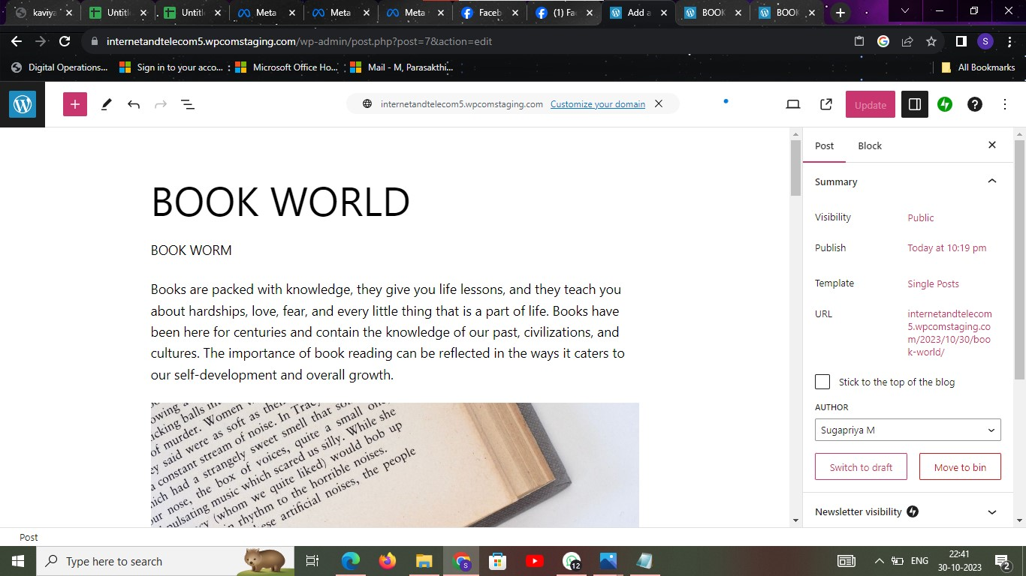

2.Create a new facebook business page and post one social media

poster for your brand.

<https://www.facebook.com/profile.php?id=61553043776559>

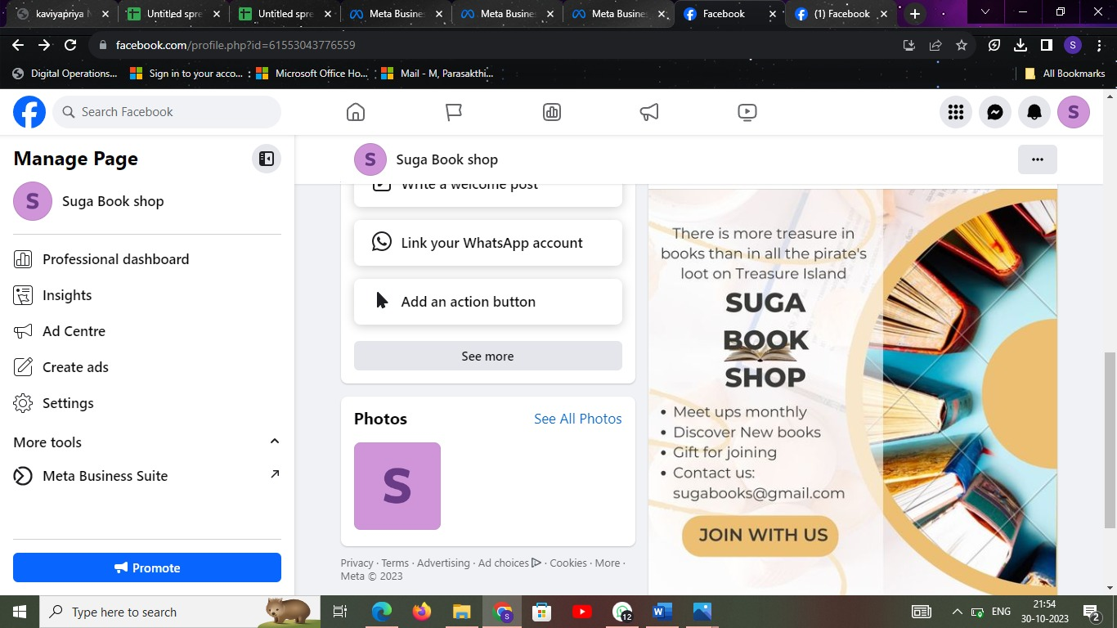

3.Create and design a social media advertisement poster using canva.



4. Create email newsletter design using Mailchimp or canva tool.

